

***ENVIRONMENT PROTECTION AND BIODIVERSITY CONSERVATION ACT 1999***

**Part 10 Strategic Assessment**

**Section 146 Agreement**

Relating to the assessment of the impacts of urban development at Gungahlin, Australian Capital Territory, under the *Environment Protection and Biodiversity Conservation Act 1999*

between

**THE COMMONWEALTH OF AUSTRALIA**

and

**THE AUSTRALIAN CAPITAL TERRITORY**

1 PARTIES 3

2 DEFINITIONS 3

3 PREAMBLE 3

4 BACKGROUND 3

5 TERMS OF REFERENCE FOR THE STRATEGIC ASSESSMENT REPORT AND PLAN 3

6 PREPARATION OF THE STRATEGIC ASSESSMENT REPORT AND PLAN 3

7 CONSIDERATION OF THE STRATEGIC ASSESSMENT REPORT AND PLAN 3

8 ENDORSEMENT OF THE PLAN 3

9 APPROVAL OF ACTIONS 3

10 GOVERNANCE ARRANGEMENTS 3

11 VARIATION 3

12 DISPUTE RESOLUTION 3

13 TERMINATION 3

Attachment A: Geographic Area 3

Attachment B: Terms of Reference 3

## PARTIES

The parties to this agreement are:

The Commonwealth of Australia, represented by the Department of Sustainability, Environment, Water, Population and Communities (the department) as delegate for the Minister administering the *Environment Protection and Biodiversity Conservation Act 1999*

and

The Australian Capital Territory Government, represented by the Director General for Economic Development Directorate for the ACT Minister for the Economic Development and the Director General of the Environment and Sustainable Development Directorate for the ACT Minister for Environment and Sustainable Development.

## DEFINITIONS

* 1. Unless stated otherwise in this agreement, the definitions, meanings and terms in the *Environment Protection and Biodiversity Conservation Act 1999* (EPBC Act) apply to this agreement and attachments.
  2. In this agreement:

***ACT*** means the Australian Capital Territory

***Department*** means the Commonwealth Department of Sustainability, Environment, Water, Population and Communities

***EPBC Act***means the *Environment Protection and Biodiversity Conservation Act 1999* (Commonwealth)

***Minister*** means the Minister or delegate responsible for administering the *EPBC* Act

***Matters of National Environmental Significance*** or ***MNES*** means the matters protected by the provisions of Division 1 of Part 3 of the EPBC Act. For the purposes of this strategic assessment, a reference to MNES is also a reference to any additional threatened ecological communities and species protected under the ACT *Nature Conservation Act 1980*

***Plan*** means the *Gungahlin Development Plan* prepared by the Economic Development Directorate of the ACT Government

***Strategic Assessment Report*** means the report assessing the impacts of actions taken in accordance with the Plan on MNES.

* 1. In this agreement references to the singular include the plural.

## PREAMBLE

3.1 The parties agree that significant environmental, social and economic values may be derived from implementing the Plan.

3.2 Recognising those significant environmental values, the parties commit to undertake a strategic assessment of the impacts of actions under the Plan on MNES protected by Part 3 of the EPBC Act.

3.3 The parties agree to share information and work cooperatively with all relevant Territory and Commonwealth agencies, to the fullest extent practical, so as to avoid duplication of work in undertaking this strategic assessment (and subject to meeting requirements under the EPBC Act).

## BACKGROUND

4.1 Section 146(1) of the EPBC Act allows the Minister to agree in writing with a person responsible for the adoption or implementation of a policy, plan or program that an assessment be made of the impacts of actions under the policy, plan or program on MNES. For the purpose of section 146(1) of the EPBC Act this agreement relates to the Plan as defined in clause 2.2. The Plan describes avoidance, mitigation and offset arrangements for MNES impacted by development or classes of actions.

4.2 The class of actions to be considered under this strategic assessment are actions associated with the development of the suburbs of Jacka, Taylor, Kinlyside, Crace, Horsepark North, Throsby and Kenny, and all associated infrastructure. A map of the strategic assessment area is at **Attachment A**. This shows the relevant impact assessment areas together with the broader area considered for MNES and biodiversity offsets.

4.3 An assessment of the impacts on MNES from implementation of the Plan will be undertaken and described in a draft Strategic Assessment Report. The draft Strategic Assessment Report and draft Plan will be made available for public comment for a minimum of 28 calendar days in accordance with section 146 of the EPBC Act. A revised Strategic Assessment Report, or the draft Strategic Assessment Report together with a Supplementary Report addressing public comments, and the revised Plan, will then be submitted to the Minister.

4.4 Section 146(2)(e) provides for the Minister to make recommendations for modifications to a policy, plan or program. The Minister may decide to endorse the Plan in accordance with section 146(2)(f) of the EPBC Act if he or she is satisfied that the Strategic Assessment Report adequately addresses the impacts to which this agreement relates and that any recommended modifications, or modifications having the same effect, have been made to the final Plan.

4.5 The parties acknowledge that the endorsement of the Plan itself does not necessarily constitute any approval under the EPBC Act for the taking of actions for which approval is required under the EPBC Act.

4.6 If the Minister endorses the Plan, the Minister may then, under section 146B of the EPBC Act, approve the taking of an action, or a class of actions, in accordance with the endorsed Plan. Approvals may be considered at the same time as endorsement of the Plan. The effect of an approval decision is that actions or class of actions approved under section 146B would not need further approval from the Minister under the EPBC Act if taken in accordance with the endorsed Plan.

4.7 The parties acknowledge that where proponents propose to take an action in accordance with the Plan, that is not the subject of an approval under section 146B, they are still capable of seeking approval for that action via the ordinary channels for assessment and approval established under Parts 7, 8 and 9 of the EPBC Act. Further, sections 87(3)(b) and 136(2)(e) provide for the Plan to be taken into account in deciding the level of assessment and approval for actions that are referred via ordinary channels.

4.8 The parties will develop a joint Project Plan outlining a schedule (including key milestones, component activities and deliverables), allocation of resources, and governance, communication and data sharing agreements for the Plan and Strategic Assessment Report.

## TERMS OF REFERENCE FOR THE STRATEGIC ASSESSMENT REPORT AND PLAN

5.1 The parties agree on the terms of reference for the Strategic Assessment Report and Plan at **Attachment B**. The terms of reference have been prepared pursuant to section 146(1B)(a) of the EPBC Act.

## PREPARATION OF THE STRATEGIC ASSESSMENT REPORT AND PLAN

6.1 The ACT Government is responsible for preparing and publicly exhibiting:

1. a draft Strategic Assessment Report in accordance with this Agreement and the Terms of Reference at **Attachment B**; and
2. a draft Plan in accordance with this Agreement and the Terms of Reference.

6.2 The ACT Government agrees to provide the draft Strategic Assessment Report and Plan to the department for comment prior to them being released for public comments in accordance with the joint Project Plan. The department agrees to assist the ACT Government in ensuring that the draft Strategic Assessment Report and Plan adequately address the requirements for strategic assessments described in Part 10 of the EPBC Act and to provide comments in a timely manner as agreed in the joint Project Plan.

6.3 The ACT Government will provide the draft Strategic Assessment Report and Plan and for public comment by notice:

1. posted on the ACT Department of Environment and Sustainable Development, and Economic Development Directorate websites; and
2. published in newspapers circulating in the ACT.

The notice must advise that the draft Strategic Assessment Report and Plan are available and how copies may be obtained, provide contact details for obtaining further information, and invite public comments on the draft Strategic Assessment Report and Plan for a period specified by the Minister of at least 28 days.

6.4 The Parties:

1. should each notify interested parties, including principal stakeholders, of the notice in section 6.3 and of the availability of the draft Strategic Assessment Report and Plan; and
2. will each make copies of the draft Strategic Assessment Report and Plan available electronically through their websites, and in print via post if requested.

6.5 The ACT Government will prepare a revised Strategic Assessment Report, or a Supplementary Report to the draft Strategic Assessment Report, and a revised Plan taking account of the comments received.

The ACT Government agrees to provide drafts of these documents to the department for comment prior to their finalisation in accordance with the joint Project Plan. The department agrees to assist the ACT Government in ensuring that the Strategic Assessment Report and Plan adequately address the requirements for strategic assessments described in Part 10 of the EPBC Act and to provide comments in a timely manner.

## CONSIDERATION OF THE STRATEGIC ASSESSMENT REPORT AND PLAN

7.1 The ACT Government will submit to the Minister:

1. the final Strategic Assessment Report, comprised of:
2. a revised draft Strategic Assessment Report, or
3. the draft Strategic Assessment Report and a Supplementary Report;
4. the final Plan;
5. a summary of public comments received on the draft Strategic Assessment Report and Plan; and
6. any other documents required to support the ACT Government’s submission.
   1. The Minister may request further information or clarification if not satisfied that the final Strategic Assessment Report adequately addresses the impacts of the actions to which this Agreement relates.
   2. The Minister may make recommendations to the ACT Government about the Plan, including recommendations for modification of the Plan pursuant to section 146(2)(e) of the EPBC Act.
   3. If the Minister makes recommendations to the ACT Government about the Plan:
7. the ACT Government may seek clarification from the Minister on these recommendations;
8. the ACT Government will then submit to the Minister for consideration the revised Plan and a summary of how the Minister’s recommendations were given effect;
9. the Minister will consider the revised Plan, and any supporting material provided, and may accept it as the final Plan; and
10. the Minister may request further modifications if still not satisfied that the Plan adequately addresses the impacts of the actions to which this Agreement relates.

## ENDORSEMENT OF THE PLAN

* 1. The Minister may endorse the Plan if satisfied that:

1. the final Strategic Assessment Report submitted under clause 7.1 adequately addresses the impacts to which this Agreement relates; and
2. any recommended modifications to the Plan (clause 7.3), or modifications having the same effect, have been made to the Plan.
   1. In considering whether to endorse the Plan the Minister will also consider the endorsement criteria in the Terms of Reference at **Attachment B**. The Minister will also have regard to the extent to which the Plan meets the objectives of the EPBC Act. In particular, that it:
3. protects the environment, especially MNES;
4. promotes ecologically sustainable development;
5. promotes the conservation of biodiversity; and
6. provides for the protection and conservation of heritage.

## APPROVAL OF ACTIONS

9.1 The Minister may approve, or approve with conditions, under section 146B of the EPBC Act, the taking of an action or class of actions in accordance with the endorsed Plan. In doing so, the Minister must act in accordance with sections 146F-M of the EPBC Act. This includes considering relevant MNES, the environment of Commonwealth land, economic and social matters, and principles of ecologically sustainable development.

9.2 The Minister will seek comment from any other Commonwealth Ministers with administrative responsibilities relating to the actions or class of actions before approving the taking of an action, or class of actions, in accordance with section 146C of the EPBC Act.

9.3 Both Parties will make the approval decision and the endorsed Plan publicly available electronically through their websites, and in print via post if requested.

## GOVERNANCE ARRANGEMENTS

10.1The parties will, under a best endeavours approach, establish agreed timelines within two weeks of the signature of this agreement for deliverables and arrangements to ensure adequate communications to progress the strategic assessment. This includes preparation of a joint Project Plan by the parties (clause 4.8). The parties will meet at regular intervals to exchange information and monitor progress against scheduled milestones and deadlines.

## VARIATION

11.1The parties may vary this agreement by an exchange of letters or electronic communications to the extent only that such variation is consistent with the provisions of the EPBC Act.

## DISPUTE RESOLUTION

12.1 Where there is a dispute between the parties to this agreement on a particular matter, the parties will consult in a spirit of cooperation in relation to that matter and will use their best endeavours to negotiate a mutually acceptable resolution.

## TERMINATION

13.1 This agreement may be terminated by written agreement (including by way of electronic communication) between the parties.

SIGNED BY:

Signed

_________________________________________ on___2___/__10__/2012

Kimberley Dripps

Deputy Secretary

Department of Sustainability, Environment, Water, Population and Communities

Signed

_________________________________________ on___26__/__9___/2012

David Papps

Director General Environment and Sustainable Development Directorate

ACT Government

Signed

_________________________________________ on___24__/___9__/2012

David Dawes

Director General Economic Development Directorate

ACT Government

## Attachment A: Geographic Area

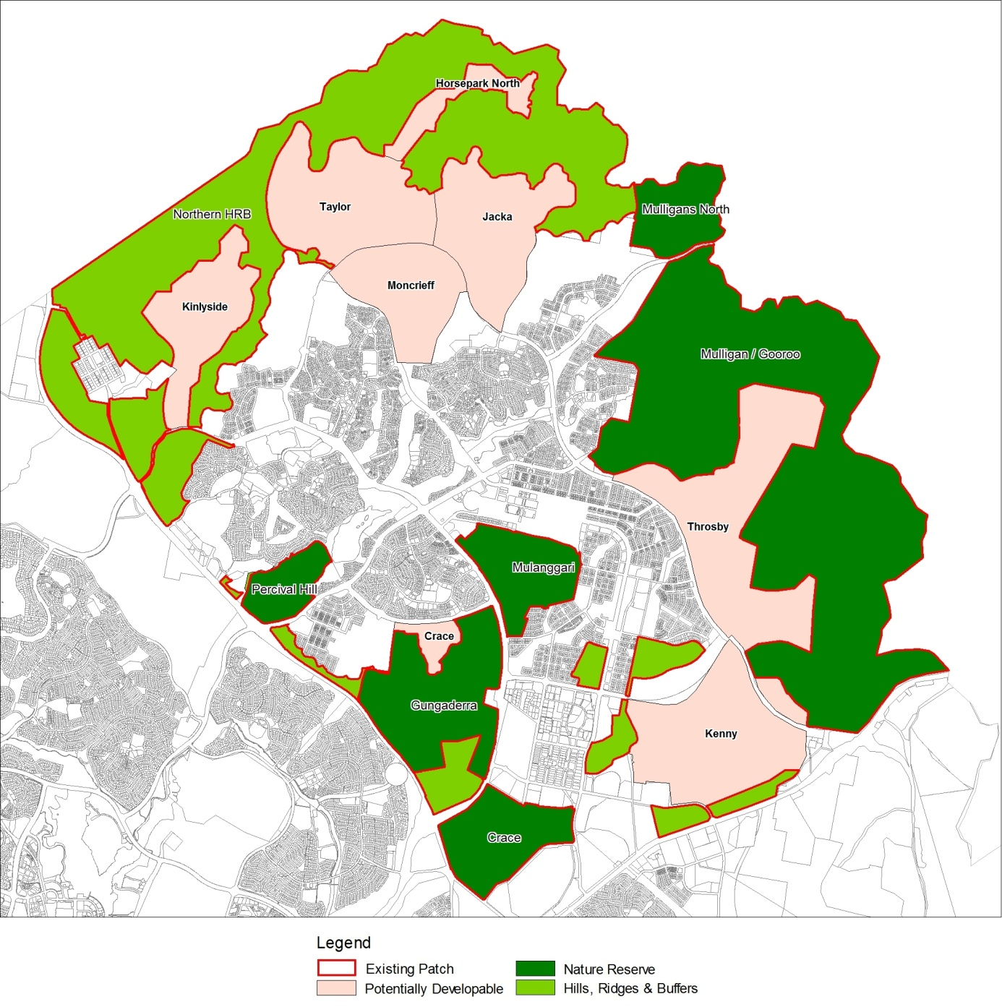

## Attachment B: Terms of Reference

**Terms of Reference for the Strategic Assessment Report and Plan for developments in Gungahlin, ACT**

**1 purpose and description**

The Plan must describe:

1. The geographic extent and description of the area to which the Plan applies, including tenures, identification of current protected lands and the location of developable and non-developable land.
2. The Territory context (environmental, social and economic) in which the Plan operates.
3. Component legislation, plans, statutes, planning instruments and policies that underpin the Plan and its implementation.
4. Specific outcomes and commitments to protect matters of national environmental significance (MNES) listed under the EPBC Act, as well as any additional threatened ecological communities and species protected under the ACT *Nature Conservation Act 1980*[1].
5. Key studies and investigations that have informed the Plan and Strategic Assessment Report.
6. Description and justification for methodologies used to identify and prioritise desirable conservation outcomes for the area to which the Plan applies.
7. Mechanisms, including avoidance, mitigation and offset arrangements, to achieve the identified conservation outcomes.
8. Identification of the relevant authorities responsible for implementation of the Plan, particularly in relation to conservation commitments, adaptive management approaches, monitoring, auditing, reporting and compliance arrangements.

**2 MATTERS OF NATIONAL ENVIRONMENTAL SIGNIFICANCE (MNES)**

**2.1 Identification of affected MNES**

The Strategic Assessment Report must describe MNES likely to be impacted by actions envisaged in the Plan. The following matters must be addressed:

* Listed threatened species and communities (sections 18 and 18A);
* Listed migratory species (sections 20 and 20A); and
* The environment on Commonwealth land (sections 26 and 27A).

The Strategic Assessment Report must describe the MNES within the geographic extent of the Plan. This includes the MNES likely to be directly or indirectly impacted. The assessment must:

1. Describe the current condition of MNES, and past and projected trends and existing threats;
2. Identify those aspects of the environment, including landscape-scale ecosystem functions and connectivity corridors, considered critical to the continued presence and functioning of MNES identified as potentially at risk;
3. Describe the methodology for identifying MNES and supporting landscape ecosystem functions and connectivity, and for identifying priority areas for conservation, together with an analysis of the strengths, limitations and expected effectiveness of methodologies used; and
4. Identify any key information gaps, further studies needed and any proposals to address critical information needs.

**2.2 Identification and analysis of potential impacts**

The Strategic Assessment Report must identify and analyse the likely direct and indirect impacts of development on biodiversity and MNES within the strategic assessment area, and against the desired conservation outcomes identified in the Plan. The report should include analysis of the:

1. Nature of potential development and description of the types of impacts considered, including cumulative impacts;
2. Potential impacts on MNES and those aspects of the environment considered critical to the continued presence and functioning of MNES;
3. Sensitivity analysis of different development scenarios on achieving the desired conservation outcomes identified in the Plan; and
4. Consideration of climate change and other long term influences on MNES and supporting landscape ecosystems in assessing likely risks and impacts to biodiversity from development.

**2.3 Measures to avoid, mitigate, offset and adaptively manage impacts**

The Plan and Strategic Assessment Report must identify specific measures that have been, or will be, implemented to avoid, mitigate and offset impacts on MNES, including:

1. Measures to identify and avoid areas of high conservation or biodiversity value;
2. Requirements for mitigation of impacts where direct or indirect impacts are expected or likely;
3. Offset mechanisms and approaches to be applied where clearing of native vegetation is proposed within development area, and to direct offsets to priority conservation areas identified in the Plan; and
4. The agencies responsible for undertaking the proposed measures.

The Strategic Assessment Report must include an analysis of the likely effectiveness of the Plan in protecting MNES and in achieving good conservation outcomes at the regional landscape scale, including associated regulatory and policy arrangements to implement commitments.

**3 Promoting Ecologically Sustainable Development**

The Strategic Assessment Report must describe how the principles of ecologically sustainable development (section 3A of the EPBC Act) have been applied in developing the Plan and how these will be implemented.

**4 ADAPTIVE MANAGEMENT: ADDRESSING UNCERTAINTY AND MANAGING RISK**

The Plan and Strategic Assessment Report must identify key adaptive management measures addressing uncertainties and inherent risks. Uncertainties could, for example, include knowledge gaps in scientific understanding and the timing, effectiveness, or capacity to implement, maintain, operate and enforce management measures.

The Plan must describe how the adaptive management strategies will be implemented to ensure MNES are effectively protected over the life of the Plan. This includes:

1. How monitoring of MNES will occur, including monitoring of progress in achieving the desired conservation outcomes identified in the Plan, how the monitoring will be analysed throughout the life of the Plan and how the results of the monitoring will influence the Plan; and
2. How new information relating to MNES or the Plan is to be assessed and accounted for in management of the area affected by the Plan.

**5 auditing and reporting**

The Plan must set out:

1. Monitoring, public reporting and independent or third party auditing to be undertaken;
2. A process that will incorporate these findings into ongoing management;
3. Who is responsible for overseeing and taking these actions; and
4. Record keeping and review processes under the Plan.

**6 REVIEW, MODIFICATION OR ABANDONMENT**

The Plan must identify and analyse the likely circumstances and procedures that may result in the review, modification or abandonment of the Plan. This is to include a discussion of how any commitments under the Plan will continue to be met.

**7 ENDORSEMENT CRITERIA**

In determining whether or not to endorse the Plan, the Minister will have regard to the extent to which the Plan meets the objectives of the EPBC Act including how the Plan:

1. protects the environment, especially MNES;
2. promotes ecologically sustainable development;
3. promotes the conservation of biodiversity;
4. promotes a cooperative approach to the protection and management of biodiversity and MNES; and
5. assists in the co‑operative implementation of Australia’s international environmental responsibilities.

Commitments for the protection and management of MNES must be enforceable and achievable over the life of the Plan. The Plan must demonstrate an effective system of adaptive management that addresses uncertainty and contingency management as well as procedures for monitoring, auditing and public reporting on implementation.

**8 INFORMATION SOURCES**

For information and data used in the assessment, the Strategic Assessment Report must state:

1. The source and currency (date) of the information; and
2. The reliability and limitations of the information.

1. For the purposes of these ToR, a reference to MNES should be read as also including ACT-listed threatened ecological communities and species to which the strategic assessment also applies.